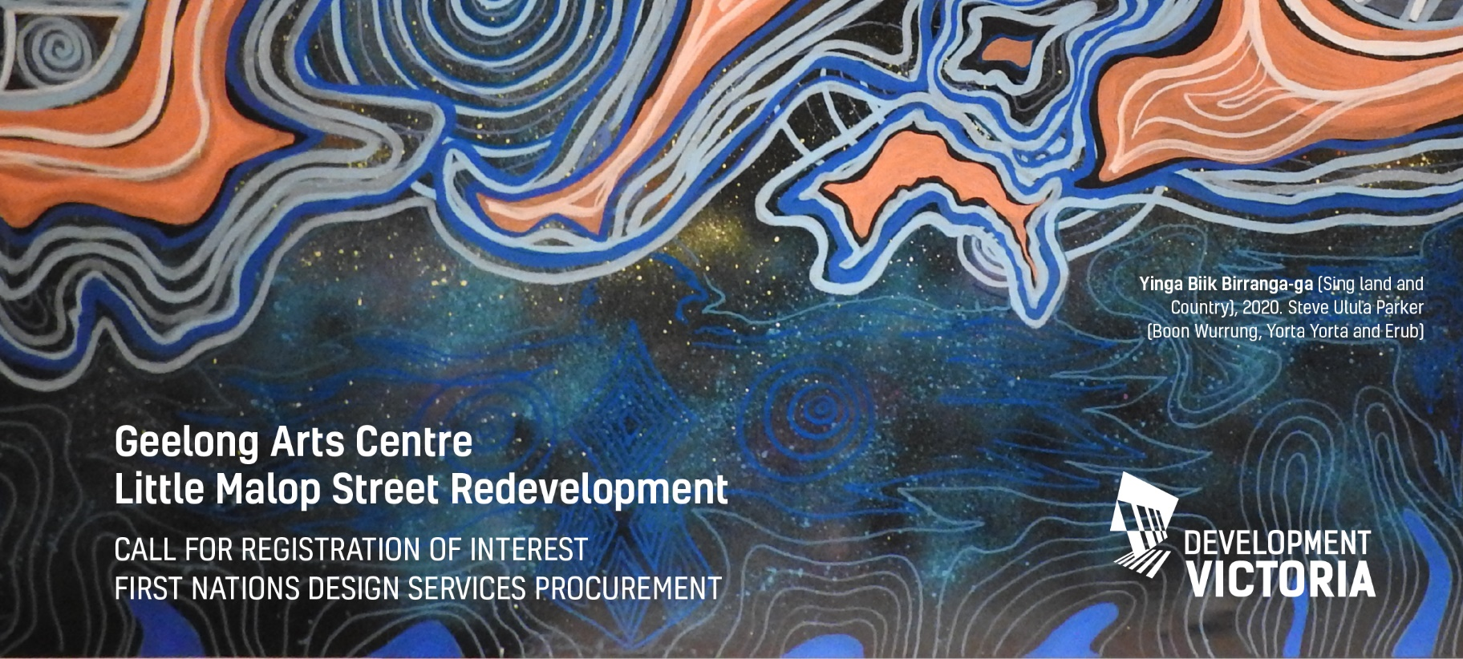

Geelong Arts Centre Little Malop Street Redevelopment

CALL FOR REGISTRATION OF INTEREST
FIRST NATIONS DESIGN SERVICES PROCUREMENT

Context and Background
Established in 1981, Geelong Arts Centre has been at the heart of creative and cultural life in Geelong and the region for 40 years.
The Centre currently engages diverse audiences with high calibre theatre, music and dance performances and events from across Victoria, Australia and the world.
The Centre also provides Geelong with a facility to attract, develop and present locally produced works that are then showcased in other cities.
Geelong Arts Centre also fosters and grows community creativity and performance. Audiences are able to enjoy the world’s best theatre, music and performances, as well as tap into their own creative potential.
Geelong Arts Centre believes in the power of theatre to provide new perspectives; challenge thinking and reveal otherwise hidden sides to our stories and ideas. Seeking out and embracing creativity can transform minds, shift ideas and encourage us to reconsider our preconceptions.
Little Malop Street Redevelopment
The Little Malop Street Redevelopment presents a once in a generation opportunity to redevelop an iconic cultural facility for the people of Geelong and Victoria to learn, experience and enjoy.
The vision for this cultural precinct is to complement and strengthen the cultural diversity of Geelong and the State’s visual and performing arts venues and cultural institutions.

Project Aim and Scope
The project seeks to engage four practicing Victorian First Nations Artists, or a consortium comprising at least fifty percent representation by Victorian First Nations artist(s), or an agent who represents Victorian First Nations Artists, to work with the design and project team to develop imagery and soundscapes. These works will be incorporated into four different locations within the built fabric, and aim to inspire, affirm, provoke, embrace and embolden culture for this region.
Procurement Process
The Project is seeking Victorian First Nations visual and sound artists to register their interest by 5pm on Thursday 29 July 2021 at gac.stage3@development.vic.gov.au
The following information is required:
- A brief portfolio including examples of relevant works of visual or sound artistry
- A current Curriculum Vitae including contact name, email, and phone number
The Evaluation Committee will include members of the Project Team, including a Wadawurrung Traditional Owner representative and a Geelong First Nations community member. The Evaluation Phase will identify a shortlist of Victorian First Nations Artists to proceed to Expression of Interest (EOI) Phase. This will then involve an interactive workshop with members of the project team. On completion of the evaluation, Victorian First Nations Artists will be engaged by the Project to develop a design concept to integrate into Geelong Arts Centre’s final design.

