The revitalisation of Central Pier and adjacent waterfront
Community Engagement Summary Report
1 August 2023

Contents
Executive summary 3
Introduction 5
Project background 5
Involving community and stakeholders 5
How we engaged 7
Engagement questions 7
Feedback on the draft vision statements 7
Communication and promotion activities 9
Engagement activities 10
Participants 12
Engagement findings 14
Refining the draft vision statements 14
Bringing the vision statements to life 18
Engagement limitations 23
Conclusion 23
Next steps 24
Appendix 26

Executive summary
At Development Victoria, we create places for people. We reimagine iconic places like the Melbourne Arts Precinct and State Basketball Centre; develop precincts like Docklands and Fitzroy Gasworks; and build affordable and diverse homes where they’re needed.

We’re a government agency delivering places that make a genuine difference to the people of Victoria, and we partner with government, industry and community to make it all happen.
Development Victoria is progressing plans to revitalise Central Pier and the adjacent waterfront following
the closure and subsequent decision to demolish Central Pier due to structural issues that represented a serious risk to public safety.
The first stage in the revitalisation project is the development of a Place Principles and Vision Strategy to guide the development of future concepts for the area.
To help inform the preparation of the Place Principles and Vision Strategy, Development Victoria invited the community to share their visions for Central Pier and the adjacent waterfront. From 15 October to 22 December 2022, 295 people participated in engagement activities which included a combination of online and in person workshops as well as an online survey on the Engage Victoria website.
To help start the conversation, Development Victoria presented 10 vision statements.
Two were previously established statements, and eight were drafted for community feedback. The two established principles of ‘First Nations connection’ and ‘accessible for all abilities’ are core principles of the project and reflects Development Victoria’s organisational commitments.
Participants expressed that they were mainly very comfortable or comfortable with the draft vision statements (see Figure 1). Suggestions for improving the vision statements focused on:
- ensuring the site is not over-commercialised and has the right mix of commercial and public activities
- recognising that local and visitor needs, or interests, may conflict, and there is a need to ensure future uses do not negatively impact residents
- ensuring there is a greater focus on enhancing the natural environment and providing opportunities for visitors to connect with nature and water • creating something uniquely Docklands and connecting people to the area’s culture and heritage.
Development Victoria invited participants to share their ideas for how the vision could be brought to life under a series of themes. The following dot points summarise what was heard under each theme:
A unique and vibrant destination
Participants described mixed-use developments with commercial and public land uses when discussing what uses would help make Central Pier and the adjacent waterfront a unique, vibrant destination. Participants also commonly shared ideas on how to make the most of the waterfront location and increase opportunities to connect with the water.
A welcoming space
Participants shared desires for Central Pier and the waterfront to become a welcoming, inclusive and appealing space for visitors and locals. Respondents described the need for the site to be visually appealing to draw people into the precinct and make everyone feel welcome. Respondents also focused on the public spaces, facilities and activities that would help people feel welcome.
Easy to get to and move around
Participants expressed general satisfaction towards the existing infrastructure and amenities to support their movements in and around Central Pier. To further enhance this, participants discussed the expansion of the public transport network and services, improvements in active transport planning and design, and additional car parking spaces.
Showcase the themes of environment and sustainability
Participants discussed the use of green spaces, ecosystems, use of renewable energy, use of recycled materials and effective management as ways of showcasing environmental sustainability. Participants also described ideas for making the environmental sustainability elements interactive to promote education.
Rich culture and heritage
Participants generally shared a desire to demonstrate the rich culture and heritage of Central Pier. Participants described the need to represent both First Nations and maritime history of the site. Participants also put forward ideas for creative storytelling as a means to revitalise Central Pier.

The feedback from the community engagement process will inform the preparation of the Place Principles and Vision Strategy to ensure it reflects the community’s aspirations and vision for the revitalisation of Central Pier and adjacent waterfront.

Introduction
This report summarises the community engagement undertaken to inform the development of a strategy to revitalise Central Pier and the adjacent waterfront.
Throughout the engagement process, numerous unique ideas and visions were shared for the future of Central Pier. This report is a summary of the themes that emerged through analysing the community feedback.
The themes identified through the community engagement will be important in helping Development Victoria to refine the vision and place principles that will support the revitalisation of Central Pier and adjacent waterfront.

Project background
The Victorian Government is developing a strategy to revitalise Central Pier and the adjacent waterfront following the closure and subsequent decision to demolish Central Pier due to structural issues that represented a serious risk to public safety. The first stage in the project is the development of a Place Principles and Vision Strategy. This strategy will guide the development of future concepts for the revitalisation of Central Pier and the adjacent waterfront.
The project is in its initial stages and no decisions have been made about what will replace Central Pier or how it will be delivered.

Involving community and stakeholders
It is important for Development Victoria to understand the community’s aspirations for the revitalisation of Central Pier and adjacent waterfront from the perspective of residents, businesses and visitors to guide the project right from the start.
From 15 October to 22 December 2022, Development Victoria invited the community to share their future vision for Central Pier and the adjacent waterfront. The feedback from the community engagement process will inform the preparation of the Place Principles and Vision Strategy.
Development Victoria is also engaging directly with Registered Aboriginal Party, the Wurundjeri Woi Wurrung people, and a range of industry specialists in place-making, architecture, public space activation and sustainability.

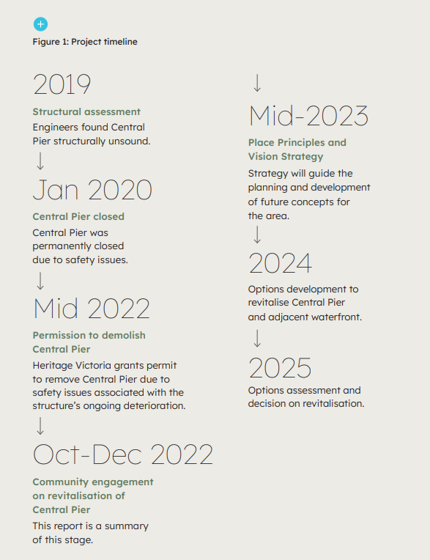

How we engaged
This chapter summarises the engagement questions asked across the engagement activities, how the engagement was communicated and promoted, and the engagement activities and limitations.

Engagement questions

Feedback on the draft vision statements
Development Victoria shared 10 vision statements, eight of which were ‘draft’ and two of which were ‘established’ (see Table 2). For each of the draft statements, participants were asked to share their overall level of comfort for each draft vision statement. Participants were also encouraged to add their own feedback on ways that the draft visions could be refined or improved.

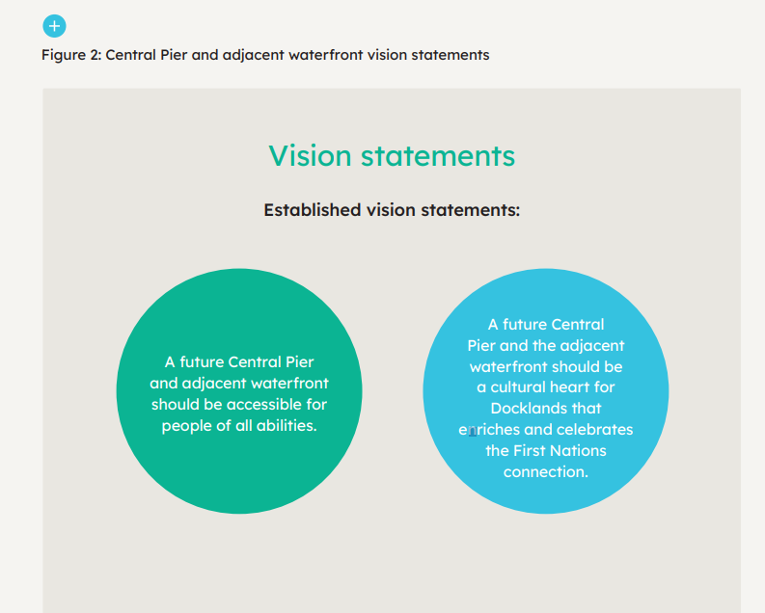

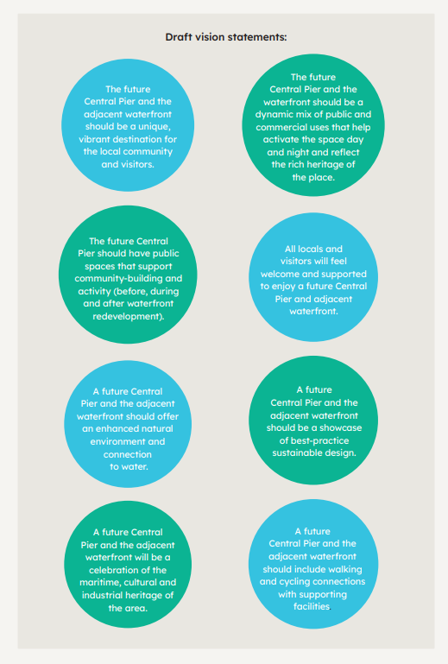

Communication and promotion activities
The engagement process for Central Pier was promoted through a number of avenues. Figure 3 summarises the communication and promotion activities undertaken and estimated overall reach of these activities.
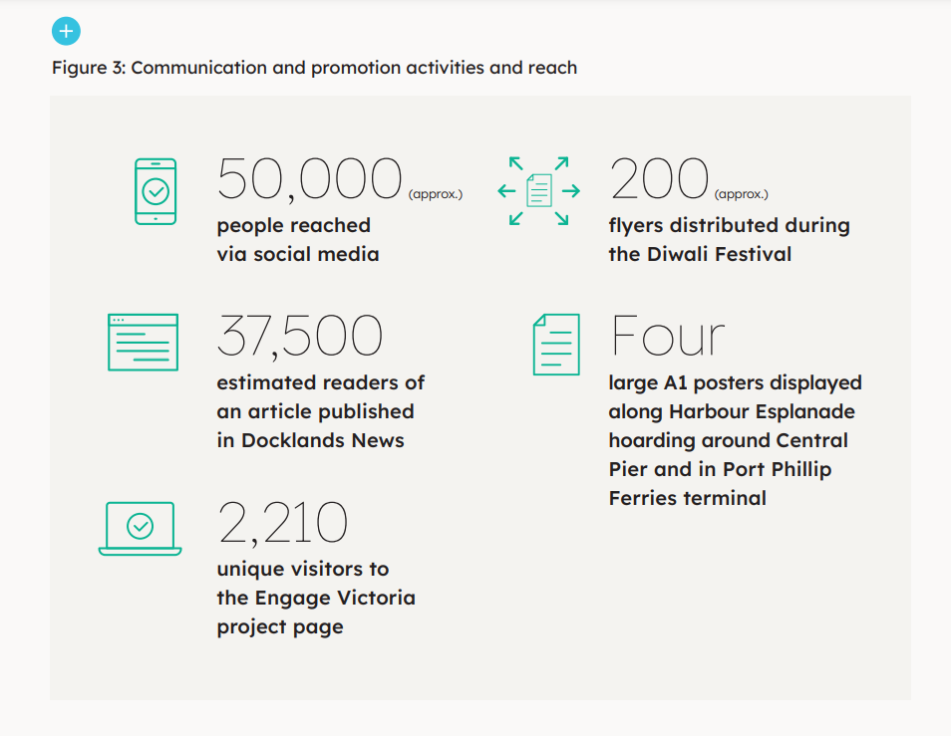

Engagement activities
Engagement activities included a combination of online and face-to-face workshops and meetings as well as an online survey. See Figure 4 for a summary of the engagement activities undertaken and participation in each. Development Victoria had planned to deliver a face-to-face workshop and host a community stall at Docklands Market. The workshop was replaced with small group conversations. Very poor weather conditions caused cancellation of the community stall at the market.

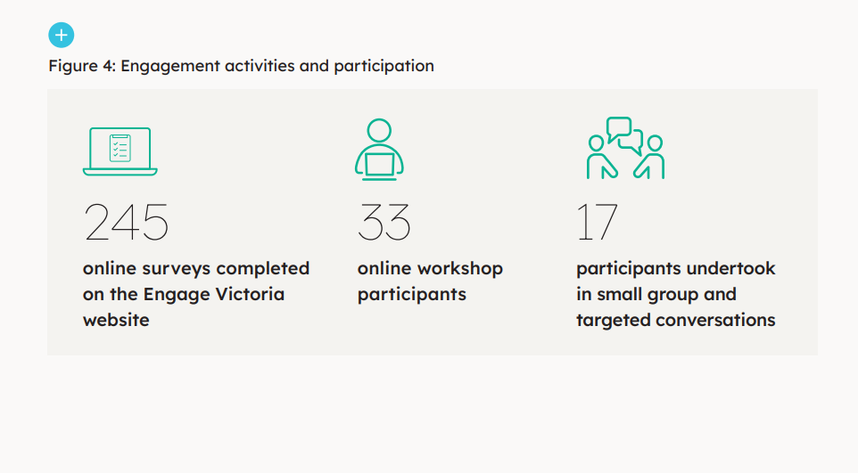

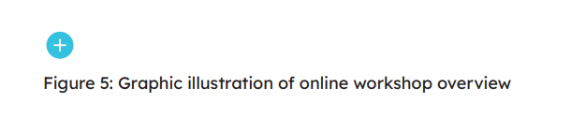
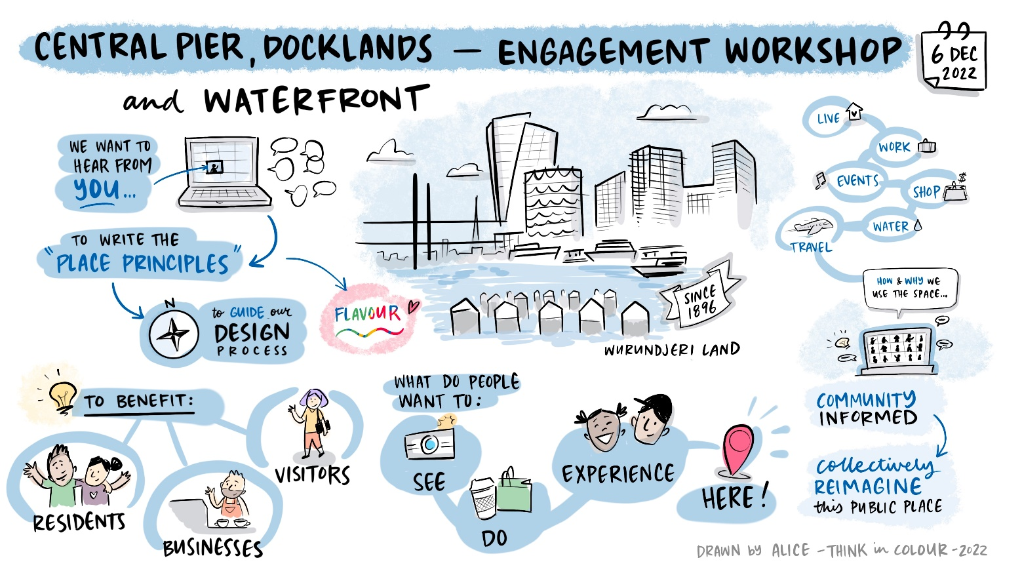

Participants
Approximately 295 people participated in the engagement activities.
The following graphs summarise the information participants shared about themselves. Demographic questions were asked in the online survey and were optional. Not everyone that completed the survey chose to answer them, while the workshop only captured participants’ relationship to Docklands and how often they visited.
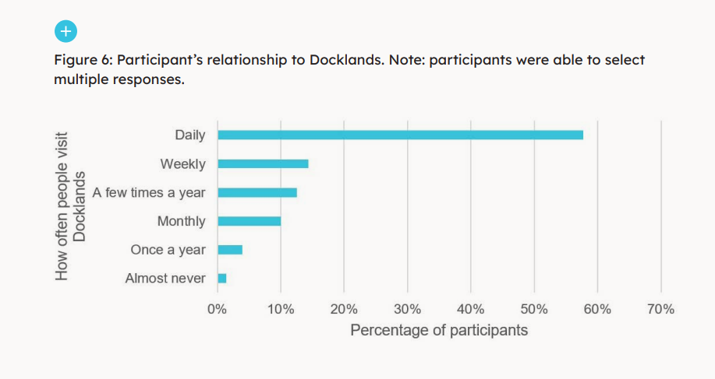
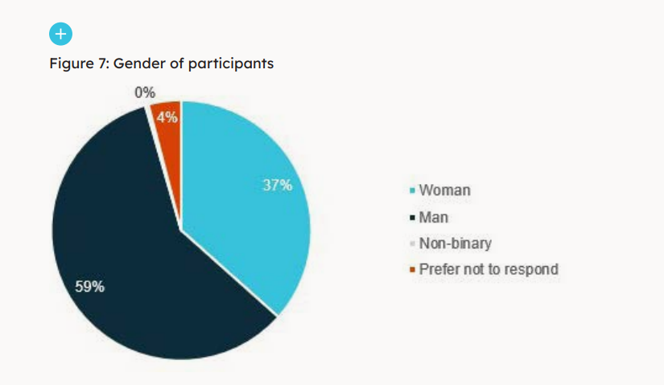

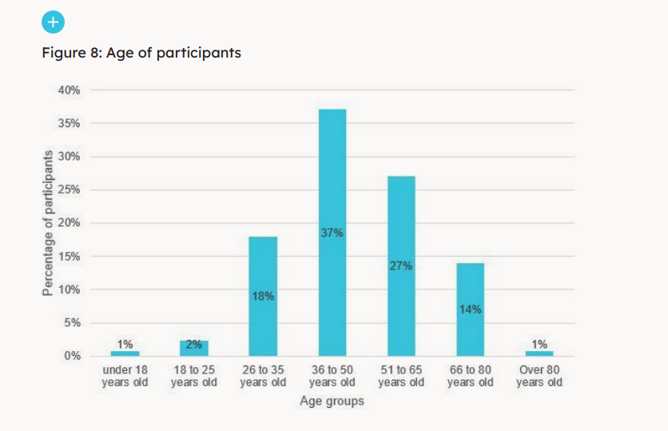

Engagement findings
“Aesthetically the public realm in Docklands should reference broader Melbourne themes and history of Docklands, but it shouldn’t shy away from being a living laboratory of new designs.” Docklands resident
The following summarises the findings from the online survey, community workshop and targeted discussions.

Refining the draft vision statements

Overall levels of comfort
Across the draft vision statements, most participants identified that they were very comfortable or comfortable with the below:
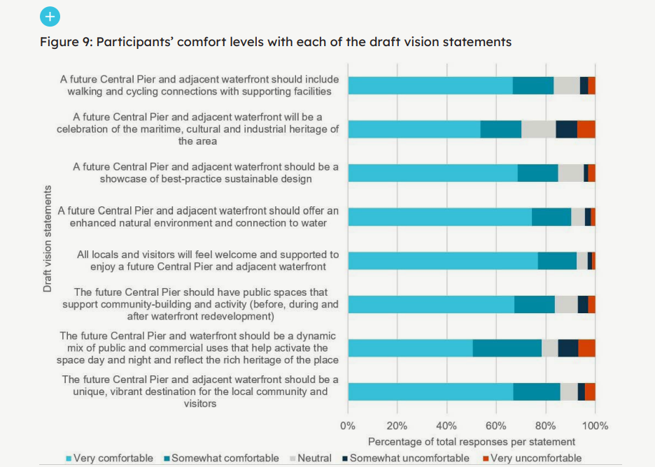

Ideas for refining the draft vision statements
“Commercial use should be a supporting use rather than a dominant use on Central Pier. There are many other opportunities in Docklands for commercial use to dominate. Central Pier should focus on public and cultural uses.” Interested community member
“The vision should be expanded to create a stronger focus on the maritime history of the docks and the relationship to the economic and social growth of Melbourne (past, present and future). This is what makes Docklands such a unique place and this should be the focus of the Vision statement.” Docklands worker
Most of the feedback shared on the draft vision statements was about the statements as a whole, rather than feedback on specific statements. There was a theme of general support for the vision statements and a mix of feedback on how the statements could be refined

The feedback on how the statements could be refined has been captured under the following themes:
Getting the balance right between commercial and public activities.
Respondents raised concerns that the vision statements do not provide enough guidance on ensuring the site is not over-commercialised. Respondents wanted greater emphasis placed on public uses.
Local and visitor needs may conflict.
Respondents discussed how local needs might be different from visitors. Respondents raised concerns about developing a tourist destination that also meets community needs. The night-time activities were raised as examples of this.
Greater focus needed on the natural environment
Respondents wanted to see green open spaces and vegetation provided as part of the revitalisation and discussed the need for the vision statements to be refined to ensure this is a focus.
Creating something that is uniquely Docklands.
Respondents agreed that any future development needs to be unique and iconic. Respondents wanted the vision to ensure that this happens by creating something that enhances what is already unique about Docklands, including its maritime history.
Some participants also shared concern that the statements were too broad. There were suggestions made around making the statements more specific to reduce the risk of misinterpretation and provide greater certainty regarding what kinds of uses will be encouraged in the precinct

Below is a graphic illustration of the feedback on the draft vision statements that was created during the online workshop.
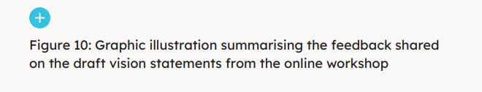
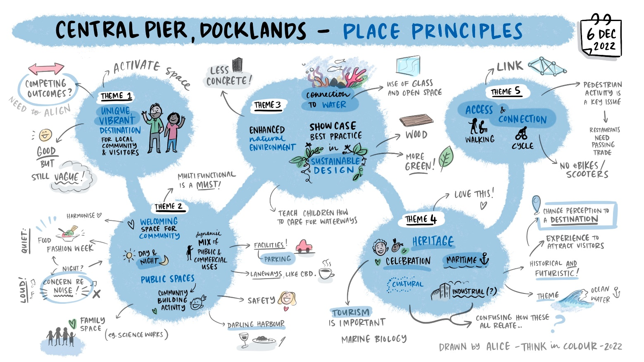

Below is a graphic illustration of the ideas shared during the online workshop on how the vision statements could be brought to life.

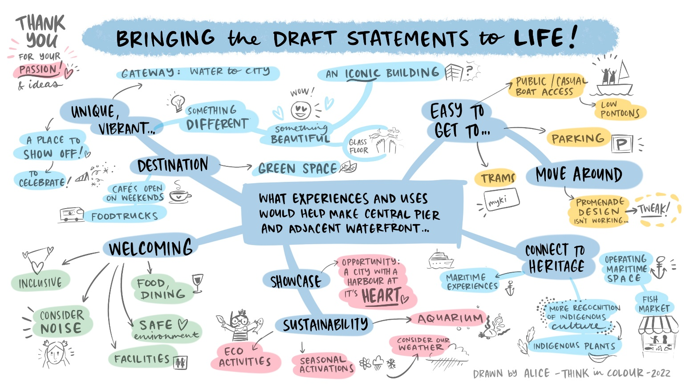

Bringing the vision statements to life
“The repurposing of this land is a once-in-a-lifetime opportunity. A structure like this would make a clear statement about who we are and what we value and if designed well, would act as the ‘new 21st century face of Melbourne’.” Docklands resident
The following sections summarise the ideas shared under each of the prompts.

A unique, vibrant destination
Participants described mixed-use developments with commercial and public land uses when discussing what uses would help make Central Pier and the adjacent waterfront a unique, vibrant destination.
Participants also commonly shared their design ideas for the site’s revitalisation, in particular, how to leverage the waterfront location and increase opportunities to connect with the water. These themes are discussed further below.
Public spaces and uses
Participants described public spaces and uses that would give the precinct a clear maritime theme and provide diverse opportunities for people to enjoy the site. Ideas for enhancing the maritime heritage of the site are discussed further on page 34.
Other participants described the need for a unique public facility that offered interactive experiences and learning, such as an art gallery or a marine science centre. More generally, participants desired public open spaces for greenery and public art, to host community events, and to connect people to the water.
Commercial activity
Participants described hospitality as an effective attractor to the precinct. Participants wanted various hospitality uses, including cafes, bars, restaurants and function venues. Participants wanted more night-time commercial offerings, but they also wanted to ensure that these uses will not have a negative impact on residents. Participants also described the benefits of an anchor retail use to draw people to the precinct. A unique market was frequently suggested for this purpose.
Participants also described the value of providing smaller commercial spaces for local entrepreneurs and pop-up commercial spaces. Other commercial activities participants identified were water-related, including ferry/cruise businesses and boat hire.
General design ideas and increasing the connection to water
Participants wanted the revitalisation of this precinct to result in an iconic design that can be compared to other world-class international waterfront destinations.
Participants discussed various examples from across the world that should be drawn from, while focusing on creating something uniquely Docklands that feels like a community precinct. Participants described designs incorporating greenery, native vegetation and water in the landscape. Some participants suggested having a global design competition to attract attention and develop unique and innovate designs.
Participants generally wanted to see more opportunities to connect to the water, both physically and visually. Some participants described having more opportunities to get into the water for swimming and other water activities. Others described desires for the design to maximise views of the water throughout the precinct.

A welcoming space
“Openness and greening of the area should be paramount, resulting in a peaceful, tranquil place for all to enjoy (not just partygoers). Having a place to relax adjacent to a ‘vibrant’ area would enhance its attraction.” Interested community member
Participants shared desires for Central Pier and the waterfront to become a welcoming, inclusive and appealing space for visitors and locals. Respondents described the need for the site to be visually appealing to draw people into the precinct and make everyone feel welcome. Respondents also focused on the public spaces, facilities and activities that would help people feel welcome. These themes are discussed further below.
Visual appeal
Participants described how unique and attractive architecture and design could help make people feel welcome and become a destination people want to visit. Participants shared ideas for enhancing the visual appeal of the precinct through enhancing views of the water, greenery, public art, water features or installations.
Public spaces, facilities and activities
Participants expressed a desire for more green public spaces to be created through the site’s revitalisation.
Participants described spaces for picnics, pets and children’s activities such as a playground. Respondents also described the need for public facilities to support the public spaces such as public toilets, seating, barbeques, waste and recycling stations and good lighting for safety.
Participants also identified the need to plan for different abilities and mobility needs. Participants described the importance of ensuring the design is appropriate for the local climate.
Participants expressed desires for the site to provide year-round protection from the weather and exposure to the wind, rain and sun.
Participants described the need to have a variety of activities that would help both locals and visitors feel welcome in the space including cafes, restaurants, bars, and food stalls with quality businesses on the waterfront that people can visit and enjoy.
Participants also saw opportunities to connect with water as a unique attractor. Having various scales of public events regularly as well as no to low-cost options were also noted as important to support the various interests of locals and visitors.

Showcase the themes of environment and sustainability
“Include an Aboriginal plant garden to educate us all on indigenous foods and their benefits. Make full use of natural light, sun and position to minimise building heating and cooling requirements and perhaps even a recycling water treatment system as part of the Aboriginal garden or small wetland area.” Docklands visitor
“Provide a visual representation of the health of the river and bay that can be tracked for us all to help improve our sustainability and environmental practices.” Interested community member
Participants discussed the use of green spaces, ecosystems, use of renewable energy, use of recycled materials and effective management as ways of showcasing environmental sustainability. Participants also described ideas for making the environmental sustainability elements interactive to promote education. These themes are discussed further below.
Green spaces and ecosystems
Participants wanted to see an enhanced natural environment through increasing biodiversity, tree coverage and improved marine health. Ideas for achieving this included community gardening, vertical greening and floating wetlands. Participants also discussed opportunities for showcasing indigenous vegetation to attract birdlife.
Promoting environmental sustainability through design
Participants expressed desires for the development to be carbon neutral and promote sustainability throughout the design. Ideas included using solar panels or ocean energy, recycling and re-use of water, effective waste management techniques and the use of recycled and repurposed materials. Participants described the value of incorporating interactive and educational elements to promote environmental sustainability. Ideas included displaying a water cleanliness gauge, or an exhibition of marine life with a water garden.

Rich culture and heritage
“In order for the Docklands Precinct to re-capture and optimise cultural tourism and consequent economic value its ‘unique’ port heritage identity, the ‘story’ needs to be told accurately.” Docklands visitor
“I think Docklands has a unique opportunity to make an iconic structure, keeping the heritage values, that will draw people to the area.” Docklands resident
Participants generally shared desire to demonstrate the rich culture and heritage of Central Pier and described the need to represent both Indigenous and maritime history of the site. They also put forward ideas for creative storytelling as a means to revitalise Central Pier. These themes are discussed further below.
Representation of Indigenous and maritime history
Participants expressed desires to showcase both Indigenous and maritime history of Central Pier and described the need to showcase the transition of Central Pier over time. Ideas included displaying historical pictures of the site, installation of artworks, and self-guided walks to demonstrate various cultural and historical aspects of the pier.
Participants also described the importance of engagement with First Nations groups and individuals to demonstrate Indigenous history of the site.
Storytelling through creative means
Participants expressed aspirations to showcase the rich culture and heritage of Central Pier through creative means. They also discussed ways to incorporate cultural and historical elements within the revitalisation of Central Pier to enhance its unique identity to both visitors and local residents. Specific ideas shared by participants included introducing urban design that reflects Central Pier’s culture and history, installing interactive virtual reality displays, adding a maritime-themed children’s play area, and hosting regular events and ceremonies by First Nations people.

Easy to get to and move around
“There is good public transport to get there, walk and cycle lines would be great facilities to enhance currently designated Docklands lines.” Docklands resident
“Tapping in to surrounding public transport, cycling paths and pedestrian links, there needs to be a desirable, walkable and comfortable environment that will attract and retain a wide mix of people to Central Pier.” Docklands visitor
Participants expressed general satisfaction towards existing infrastructure and amenities to support their movements in and around Central Pier. To further enhance this, participants discussed the expansion of the public transport network and services, improvements in active transport planning and design, and additional car parking spaces. These themes are discussed further below.
Public transport network and services
Participants described a need to expand the existing public transport network and services connecting Central Pier and its surrounds. More specifically, they said they would like to have more frequent tram and bus services, and an expanded free tram zone to encourage use of public transport for daily commutes and during events. There was also desire for more sheltered and wheelchair-friendly tram stops.
Public transport connections from Central Pier to Southbank was raised by participants as a desired transport improvement.
Participants also discussed the possibility of introducing water taxis and allowing boat access to Central Pier connecting with sites along the Yarra River.
Car parking spaces
Participants described the need to increase the number of car parking spaces for easier access to Central Pier by visitors and suggested easing parking restrictions on weekends.
Active transport planning and design
Participants expressed desires to have more inclusive active transport planning and design
such as designated pedestrian and cycling paths to ensure safety of all users. Participants suggested ideas to create a more safe and pleasant environment for people to move around Central Pier, including increasing natural shading, improving ground surfacing, and installation of ramps and wayfinding signs.
Participants mentioned the Harbour Esplanade as a key area for improvement. Participants discussed additional pedestrian networks they would like to see in Central Pier, including connection to Southern Cross Station, Marvel Stadium, Bourke Street, and Spencer Street.

Other ideas
When asked to share other ideas, participants used this opportunity to reiterate their ideas shared during the survey or additional ideas relevant to the above themes. Where additional ideas were mentioned, they have been considered in the previous section.

Engagement limitations
This report details the participants’ views, concerns and ideas expressed during the engagement activities. The following limitations were identified when conducting and reporting on the engagement activities: •
- Some participants may have participated in more than one engagement activity, therefore it is possible that some views may have been captured more than once.
- In some instance, participants did not answer all questions, this means that some questions received fewer answers than others.
- Demographic information was not captured in the workshop, small group or targeted conversations, therefore the demographic information reported below was derived from the information provided by survey participants.

Conclusion
Throughout the engagement activities, participants were supportive of the revitalisation of Central Pier and adjacent waterfront. Participants were generous in sharing their vision and ideas for the site and expressed desires to continue to be part of the conversation about the site’s future.
Through the analysis of feedback on how the vision statements could be refined and brought to life the following key overarching themes emerged:
Getting the right mix of public and commercial activity will be critical to the project’s success.
Participants supported having commercial activity that promotes vibrancy and provides for the needs of tourists and locals. Participants also wanted to ensure that the commercial activity does not negatively impact residents, such as through excessive night-time noise or anti-social behaviour. Equally, participants wanted engaging public spaces that connect people to nature and water, the area’s First Nation’s culture, maritime history, and to provide a range of free to low-cost community activities.
Any future design needs to be both iconic and functional.
Participants commonly shared aspirations for the revitalisation to include iconic architecture and urban design. To be a thriving tourist attraction, this aspiration is considered essential. Participants also wanted to ensure that the site is accessible for all abilities through various modes of transport, promotes safety and supports environmental sustainability.
Storytelling needs to be a critical design element.
Participants wanted the site to educate and celebrate the rich culture and history of the area. Participants see enhancing and building on cultural and maritime history as making the site uniquely Docklands and, therefore, something unique to Melbourne that will support the creation of a world-class destination.

Next steps

Development Victoria thanks everyone who participated in the engagement and shared their feedback and ideas. The feedback will inform development of the Place Principles and Vision Strategy that will seek to reflect the community’s aspirations and vision for the area.
If you would to be kept up to date with the revitalisation of Central Pier and adjacent waterfront, register your interest on Development Victoria website www.development.vic.gov.au

Appendix
Approach

Approach

Public Engagement Framework 2021-2025
The approach of the Central Pier community engagement campaign was designed to align with the Victorian Government’s Public Engagement Framework 2021-2025 and its engagement principles.
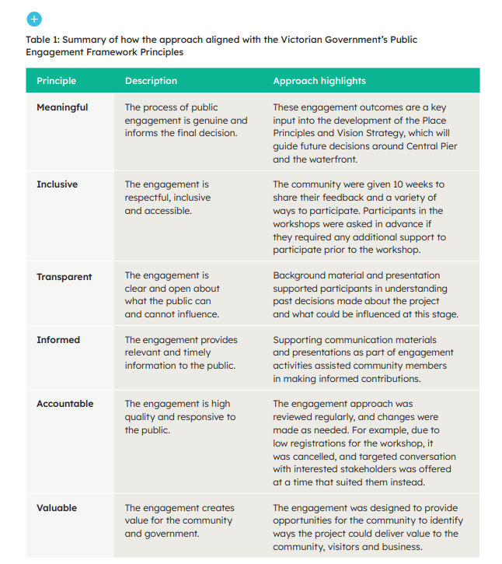

Development Victoria

Level 9, 8 Exhibition Street
Melbourne 3000
VIC Australia

GPO Box 2428
Melbourne 3001
VIC Australia

+61 3 8317 3400
development.vic.gov.au

